Enterprise Compliance AI Assistant

Technical Architecture Documentation
Document Type: System Architecture & Design Documentation
Subject System: Enterprise Compliance AI Assistant Hybrid RAG + LangGraph Agentic Architecture
Audience: Engineers, Architects, and Technical Stakeholders

Table of Contents
- Problem Statement
- Proposed Solution
- Technology Stack
- How the Architecture Solves the Problem
- Project Folder & File Structure
- High-Level Architecture Overview
- Embedding & Ingestion Pipeline Architecture
- Retrieval Layer Architecture
- LangGraph Orchestration Layer — Query Processing
- Session & Conversation Memory Architecture
- Frontend / User-Facing Layer
- Conclusion

DEVELOPED BY:
KAMALESH V

1. Problem Statement

1.1 Context
Large organizations maintain hundreds of internal policy documents spanning Human Resources, IT Security, Legal & Ethics, Finance, Engineering, and Facilities. Employees routinely need fast, accurate answers to policy questions, but two things make this a genuinely hard problem to solve with a naive chatbot: policies are regionally fragmented (different offices have different rules), and some questions are not information questions at all, but legal or ethical situations that should never be answered by an automated system.
Deploying a standard Large Language Model (LLM) or a simple Retrieval-Augmented Generation (RAG) chatbot on top of this knowledge base introduces four distinct, unacceptable failure modes.

1.2 Failure Mode 1 : Hallucination and Context Loss
Standard RAG systems retrieve the top-k most similar text chunks by vector distance and hand them, unfiltered, to a generative model. When the retrieved chunks are irrelevant, incomplete, or simply absent (because no policy exists on the topic), an LLM's default behavior is to bridge the gap with plausible-sounding, entirely fabricated content. The response reads exactly as confidently as a correct one; there is no signal available to the employee that distinguishes a grounded answer from an invented one. In a regulated enterprise context, an employee acting on a fabricated policy statement is a tangible liability event, not an inconvenience.

1.3 Failure Mode 2 : Regional Policy Contradiction
Because enterprises operate across jurisdictions, the same policy topic (e.g., Paid Time Off) frequently exists as multiple, mutually exclusive documents, one per region. Consider the query "How many PTO days do I get?" If the retrieval index contains three chunks (New York: 20 days, Austin: 15 days, London: 25 days), a standard top-k retriever returns all three as context with no mechanism to distinguish "these are three valid, mutually exclusive answers depending on location" from "these are three redundant restatements of one answer." Faced with this, a generative model will typically do one of three unsafe things: arithmetic averaging (producing a fabricated blended number matching no real policy), recency bias (silently picking whichever chunk appears last in context, regardless of relevance to the asker), or confident fabrication (bridging the ambiguity with invented policy language). Cosine similarity, the mathematical basis of vector search, has no concept of contradiction, jurisdiction, or applicability; two vectors can be numerically "close" while representing mutually exclusive real-world facts.

1.4 Failure Mode 3 : Unauthorized Legal and Ethical Guidance
A categorically different risk class exists beyond factual accuracy: certain query classes, such as an employee reporting a bribery offer, asking how to respond to a regulatory subpoena, or disclosing a whistleblower situation, are not information-retrieval problems at all. They are situations where any automated, non-attorney-reviewed guidance carries disproportionate liability, irrespective of how accurate the retrieved policy text might be. The enterprise's legal exposure in these cases stems not from inaccuracy but from the fact of automated advice being rendered at all, in a domain that structurally requires human judgment and, frequently, privileged legal counsel involvement. A soft mitigation, a system-prompt instruction telling the model to "be careful" with legal topics, is a persuasive constraint on the model, not a structurally guaranteed one, and can be bypassed through adversarial phrasing or prompt injection.

1.5 Failure Mode 4 : Siloed, Single-Document Retrieval
Real workplace incidents rarely respect departmental boundaries. An employee whose corporate laptop was stolen simultaneously triggers an IT Security obligation (report the device, initiate remote wipe) and a Legal/Data Protection obligation (GDPR breach reporting, if the device held personal data). Standard RAG retrieves the single most similar document to a query; it has no native concept of "this incident requires synthesizing steps from two unrelated policy documents into one coherent action plan," and will typically surface only the most topically dominant document, silently omitting the other department's required steps.

1.6 Summary of the Problem
Failure Mode | Root Cause | Consequence
Hallucination | No confidence gate between retrieval and generation | Fabricated policy statements presented with false confidence
Regional contradiction | Vector similarity has no concept of mutual exclusivity | Averaged/incorrect numbers delivered as fact
Unauthorized legal advice | Soft (prompt-level) constraints are not structurally enforced | Enterprise legal liability from automated guidance in high-risk domains
Siloed retrieval | Top-k retrieval returns single-document context | Incomplete, dangerous incident-response instructions

2. Proposed Solution

2.1 Design Philosophy
The Enterprise Compliance AI Assistant is architected around a single governing principle: generation must never be trusted to self-regulate. Every safety property the system claims, including no hallucination, no cross-region blending, and no automated legal advice, is enforced structurally, as a hard branch in a deterministic control-flow graph, rather than persuasively, as an instruction inside a prompt. A system prompt can be argued with, misread, or adversarially bypassed; a conditional edge in a compiled state graph cannot.
This principle is implemented through an agentic state machine built on LangGraph, sitting on top of a hybrid retrieval pipeline (combining dense semantic search, sparse keyword search, and a cross-encoder relevance gate). The retrieval layer's job is to guarantee that only verifiably relevant, correctly-scoped policy text ever reaches a generative model. The orchestration layer's job is to guarantee that certain classes of query never reach a generative model at all.

2.2 Implementation Strategies
- Anti-hallucination via a hard relevance gate. A cross-encoder re-ranking stage scores every retrieved candidate against the query using full cross-attention (not simple vector distance). Anything below a conservative, tuned threshold is discarded outright. If every candidate is discarded, the system returns an explicit empty result, and the generation prompt is structurally instructed to refuse rather than answer from general world knowledge.
- Regional contradiction via a Contradiction Engine. A dedicated evaluation step inspects the region metadata of all high-confidence retrieved documents. If more than one distinct region is represented and the user has not specified their own location, the system's intent classification is force-overridden to CLARIFY, a deterministic rule that overrides whatever the LLM itself may have classified the query as.
- Unauthorized legal advice via a Legal Circuit Breaker. Queries classified as ESCALATE never reach the generative node at all. The response is a pre-written, non-generative refusal template plus compliance officer contact routing; it is a graph-level structural block, immune to prompt injection because no token of the response is model-generated.
- Siloed retrieval via Multi-Hop Synthesis. When retrieved documents span more than one department, a dedicated multi_hop_node prompts the model to synthesize a single, chronologically-ordered action plan spanning all relevant departments — explicitly instructed not to reveal that the instructions were assembled from separate source documents, since a fragmented response is both less trustworthy and harder to act on during an active incident.

2.3 Expected Outcomes
The combined effect is a system that behaves less like a conversational chatbot and more like a deterministic compliance workflow with a natural-language interface: every response is either a cited, verifiably-grounded answer; a request for missing disambiguating information; a synthesized multi-department action plan; or a hard refusal routing to a human. There is no fifth category; no path through the graph terminates in an ungrounded, freely-generated response.

3. Technology Stack

3.1 Frontend Layer

Technology | Role
React 18 | Component-based UI framework driving the chat interface
TypeScript | Type-safe development, with types mirroring backend response schemas
Vite | Build tool and development server
Tailwind CSS | Utility-first styling framework powering the design system
React Markdown + remark-gfm | Renders AI responses (including GitHub-flavored Markdown tables used for policy comparisons)

3.2 Backend Application Layer

Technology | Role
Python 3.10+ | Primary backend language
FastAPI | Asynchronous web framework exposing the REST API surface
Pydantic | Strict schema validation for all inbound requests and outbound responses
Uvicorn | ASGI server running the FastAPI application

3.3 Orchestration & Agentic Layer

Technology | Role
LangGraph | Compiles and executes the stateful, conditional-edge orchestration graph
LangChain (core interfaces) | Supporting abstractions used within the graph nodes

3.4 Retrieval & Storage Layer

Technology | Role
ChromaDB | Persistent vector store; manages the HNSW index for dense semantic search
rank_bm25 | In-memory sparse (keyword) retrieval index
(parent_docs.json) | Stores full, un-chunked "parent" policy sections keyed by ID

3.5 Machine Learning Models

Model | Role | Execution Location
Nomic Embed Text v1.5 | Converts text chunks into 768-dimensional semantic vectors | Local (on-server)
ms-marco-MiniLM-L-6-v2 (Cross-Encoder) | Re-ranks retrieved candidates for true relevance (anti-hallucination gate) | Local (on-server)
NVIDIA Nemotron (via NVIDIA NIM API) | Generative model — intent classification, parameter extraction, and final response synthesis | External API (NVIDIA NIM)

3.6 Supporting Utilities

Technology | Role
sentence-transformers | Underlying library for embedding and cross-encoder model execution
python-dotenv | Environment variable and secrets management
ThreadPoolExecutor (Python concurrent.futures) | Parallel execution of dense/sparse search and startup model pre-warming

3.7 Stack Selection Rationale
Two choices merit explicit justification. First, both the embedding model (Nomic) and the re-ranking model (Cross-Encoder) run locally rather than through an external API. This is a deliberate data-residency decision; the literal text of proprietary corporate policy documents is never transmitted to a third party during the search phase, as only the final, filtered, minimal context excerpt is sent to the external generative model. Second, NVIDIA Nemotron was selected over general-purpose alternatives specifically for its strength in strict instruction-following, which is a hard requirement for a system whose prompts contain non-negotiable formatting and refusal rules (Section 9.5) that the model must obey with very low deviation.

4. Operational Problem Solving
This section maps each architectural mechanism directly to the failure mode it neutralizes, described in Section 1.

4.1 Neutralizing Hallucination
Hallucination protection is not a single control; it is layered at three independent points in the pipeline, so that a failure at any one layer does not compromise the whole:
- Layer 1 (Retrieval Precision): Parent-child hierarchical chunking (Section 7) ensures search operates on small, high-signal-density text units, reducing the chance of retrieving a merged, ambiguous fragment in the first place.
- Layer 2 (Relevance Gate): The cross-encoder threshold (Section 8.4) discards any candidate that is not genuinely relevant to the query, regardless of how it scored in earlier ranking stages, and returns an explicit empty result if nothing survives.
- Layer 3 (Prompt-Level Enforcement): Even when documents are retrieved, the generation prompt (ANSWER_DIRECT_SYSTEM_PROMPT) contains a hard instruction to refuse rather than answer if the retrieved document set is empty — providing a redundant, prompt-level backstop to the retrieval-level gate.

4.2 Neutralizing Regional Contradiction
Because region metadata is physically attached to every indexed vector at ingestion time (Section 7.4), the router can inspect, at query time, exactly which regions are represented among high-confidence retrieved results. When more than one region is present and the user's own location was not extracted from the query, the system's intent is force-set to CLARIFY, irrespective of the LLM's own classification. This override is a deterministic Python conditional inside router.py, not a prompt instruction, so it cannot be defeated by an LLM misclassification or an unusually-phrased query.

4.3 Neutralizing Unauthorized Legal Advice
The ESCALATE path is architected so that the generative model is never invoked for its final output. The router LLM is used only to detect the presence of legal risk in a query, which is a classification task; once detected, escalate_node returns a fixed, pre-written response object, the same text every time, for every user, for every escalated query. Because this text is not generated per-request, there is no attack surface for prompt injection to alter or suppress it.

4.4 Neutralizing Siloed Retrieval
The router detects when retrieved parent sections span more than one department metadata value and routes to multi_hop_node instead of the standard answer path. This node's system prompt explicitly instructs the model to synthesize, not concatenate, the retrieved content into one chronological plan, and to bold time-sensitive deadlines extracted verbatim from the source text (never invented), ensuring both completeness and urgency are preserved across the department boundary.

5. Project Folder & File Structure

5.1 Backend : Core Orchestration
File | Purpose (2-3 lines)
main.py | FastAPI entry point. Declares REST routes, Pydantic request/response schemas, and runs a concurrent startup hook that pre-loads the embedding model, cross-encoder, and verifies the NVIDIA API key before accepting traffic.
hybrid_retriever.py | The retrieval engine. Runs dense and sparse search in parallel, fuses results with Reciprocal Rank Fusion, and applies the cross-encoder relevance gate.
requirements.txt | Pinned Python dependencies (FastAPI, LangGraph, sentence-transformers, rank_bm25, etc.) for deterministic environment builds.
.env | Runtime secrets and configuration, primarily the NVIDIA API key and model identifiers. Never committed to version control.

5.2 Graph : Intelligence Core

File | Purpose (2-3 lines)
agent_graph.py | Compiles the LangGraph StateGraph — registers all nodes and defines the conditional edges that route execution between them.
state.py | Defines the GraphState typed dictionary — the single schema threaded through every node in the graph.
router.py | The intelligent gateway. Dynamically loads the region/department taxonomy, extracts parameters and intent via LLM, and runs the Contradiction Engine.
nodes.py | Contains the isolated node functions: router_node, clarify_node, answer_direct_node, multi_hop_node, escalate_node.
prompts.py | Central repository of system prompts, including ANSWER_DIRECT_SYSTEM_PROMPT and MULTI_HOP_SYSTEM_PROMPT, each encoding strict formatting and refusal rules.
session_cache.py | Thread-safe, in-memory TTL dictionary that persists paused GraphState during clarification flows, keyed by session ID.

5.3 Data Build : Ingestion Pipeline

File | Purpose (2-3 lines)
loader.py | Parses raw Markdown documents, extracts YAML front-matter metadata, validates required fields, and performs parent/child chunking.
chroma_builder.py | Reconciles document versions (CURRENT vs. SUPERSEDED), generates embeddings, and builds the ChromaDB HNSW index with attached metadata payloads.

5.4 Frontend : User Interface

File / Folder | Purpose (2-3 lines)
main.tsx | React entry point; mounts root <App />.
App.tsx | Manages conversation history and session IDs.
lib/api.ts | Client for FastAPI backend communication.
types.ts | Interfaces mirroring backend schemas for type safety.
components/Sidebar.tsx | Navigates chat history and sessions.
components/ChatHeader.tsx | Top navigation bar with status and controls.
components/MessageBubble.tsx | Renders Markdown content and policy tables.
components/InputBar.tsx | Handles message input and submission logic.

5.5 Database : Persistent Storage

Path | Purpose (2-3 lines)
/vector_store/ | ChromaDB's SQLite-backed files containing the HNSW vector index and child-chunk embeddings.
/processed/parent_docs.json | Key-value store of full, un-chunked parent policy sections, accessed via Parent_ID.

5.6 Sample Docs : Knowledge Base
Ten seed policy documents, each carrying a YAML metadata header (document_id, version, status, region, department): two competing New York HR versions (used as the version-audit test case), one Austin and one London HR variant (used as the region-conflict test case), and single Global-scope documents for IT Security, Legal/Anti-Bribery, Finance/Procurement, Finance/Travel, Engineering Change Management, and Facilities.

5.7 Evaluation Suite
A 15-question adversarial test suite, organized into five categories (Escalate, Multi-Hop, Clarify, Anti-Hallucination, Version Audit) that map one-to-one onto the four failure modes in Section 1 plus the version-reconciliation guarantee in Section 7.3. This suite functions as a regression test — any change to the router, retrieval threshold, or prompts is validated against all 15 questions before deployment.

6. High-Level Architecture Overview

6.1 System Composition
The system is composed of four cooperating subsystems, each with a distinct responsibility and a clean interface to its neighbors:
- Presentation Tier (React frontend) — renders conversation state and reflects backend-driven UI flags; contains no independent business logic.
- API Gateway Tier (FastAPI) — validates all inbound/outbound traffic against strict schemas and exposes the system's only network surface.
- Intelligence Tier (LangGraph state machine) — owns all routing, safety, and generation decisions.
- Data Tier (ChromaDB, BM25 index, JSON parent store) — owns the indexed knowledge base and its metadata taxonomy.

6.2 End-to-End Architecture Diagram

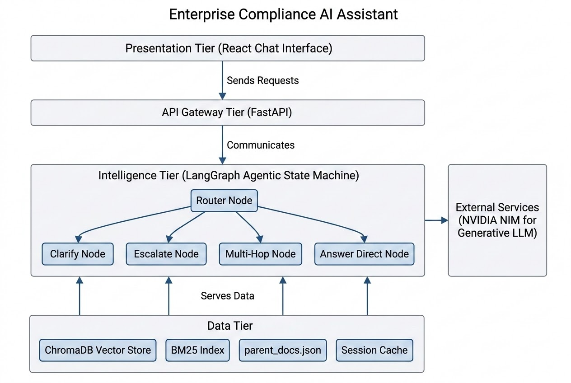

6.2 Design Paradigms

Paradigm | Problem It Solves | Alternative Considered and Rejected
Client-Server Separation | Vector/LLM compute must run on secured backend infrastructure, not the browser | Fully client-side embedding — infeasible for model size and would expose raw policy text
LangGraph State Machine | Deterministic, auditable, interruptible control flow with pause/resume support | Linear prompt chaining — cannot pause for user input or hard-block generation
Hybrid Retrieval (Dense + Sparse) | Precision on exact terms/IDs alongside semantic understanding | Pure dense vector search — blurs exact strings such as "GDPR Article 17" or "HR-POL-001"
Linear prompt chaining deserves specific rejection justification: a chain of the form extract → retrieve → generate cannot natively express "pause execution and wait for a user click, then resume with merged context" without external orchestration bolted on top as an afterthought. LangGraph's StateGraph supports this pause/resume/merge cycle as a first-class primitive via conditional edges and externalized state, which is precisely the mechanism the Clarify flow (Section 10) depends on.

7. Embedding & Ingestion Pipeline

7.1 Overview
The ingestion pipeline is the only point in the system's lifecycle where document provenance is established; every downstream guarantee in this document, including correct version, region, department, and anti-hallucination behavior, depends entirely on metadata and structure captured correctly at this stage. An error here is silent and propagates through the entire system, which is why the pipeline is designed to fail closed: any document that cannot be validated is excluded from the index entirely, rather than entering with partial or null metadata that would silently disable downstream safety checks.
The pipeline proceeds through five sequential transformations: markdown parsing and metadata validation, version reconciliation, parent-child hierarchical chunking, embedding generation, and finally HNSW index construction with metadata attachment. Each is described below, followed by a consolidated flow diagram.

7.2 Metadata Validation
loader.py opens each .md file in /sample_docs and splits it at the YAML front-matter delimiter, parsing the header block into a structured dictionary containing document_id, version, status, effective_date, department, and region. Required-field validation runs immediately after parsing: any document missing document_id, version, department, or region is rejected from the ingestion batch with a logged error, rather than being allowed to silently enter the index with partial metadata. Malformed YAML (for instance, a missing colon in the header block) causes the parser to reject the entire document outright rather than attempting a partial recovery, since a partial recovery risks silently truncating or corrupting the metadata dictionary in a way that would only surface as a mysterious downstream retrieval bug.
This fail-closed posture is a direct consequence of the compliance mandate stated in Section 1: fail-closed validation at ingestion is cheaper and categorically safer than attempting to detect missing metadata at query time. A document that fails validation simply does not exist to the retrieval system — it cannot become the source of an incorrect answer, because it is never indexed in the first place.

7.3 Version Reconciliation
The existence of an older policy revision is not itself a problem for an enterprise document system — the actual problem is an AI system being structurally unable to distinguish "this is the current, binding policy" from "this is a historical record kept for audit purposes." Version reconciliation makes this distinction explicit and machine-readable, rather than relying on file-naming conventions or human memory.
chroma_builder.py groups all successfully-loaded documents by document_id. Within each group, it performs a numeric comparison of the version field, where 2.0 > 1.0 is computed as an actual floating-point comparison, which correctly handles edge cases like 10.0 > 9.0 that a naive string comparison would get wrong. The document holding the maximum version within its group is tagged status: CURRENT; every other document in the group is tagged status: SUPERSEDED. Critically, both are still indexed; superseded documents remain fully retrievable for audit and version-comparison queries, but are excluded from the default context set used by answer_direct_node unless the user's query explicitly requests a historical comparison. Two documents sharing a document_id with an identical version number is treated as a data-integrity error; both are flagged for manual review rather than having the system arbitrarily pick a winner.
This design satisfies a concrete audit requirement common to employment disputes and regulatory inquiries: "show me what the policy said as of a given date." Deleting superseded documents entirely would make this impossible; treating superseded and current documents identically at query time would actively worsen the hallucination and contradiction risks described in Section 1.

7.4 Hierarchical Chunking
Standard fixed-window chunking, such as splitting every 200 tokens, is structurally blind to document semantics; it will happily cut a chunk boundary directly through a conditional clause, destroying exactly the semantic unit that makes the sentence meaningful. This is a well-documented failure mode in production RAG systems and is the single largest contributor to hallucination-via-context-loss.
The pipeline solves this with a deliberate two-tier strategy:
- Parent Sections (150-300 words): Documents are split strictly at major Markdown headings (##, ###). Each parent section represents one complete, self-contained policy clause with its conditions and exceptions intact. Parent sections are stored keyed by a generated Parent_ID inside parent_docs.json and are never embedded directly — they are too large and topically diverse internally for precise vector search.
- Child Chunks (50-80 words): Each parent section is further divided using a sliding-window technique with sentence-boundary overlap — each child chunk overlaps the previous by one to two sentences, ensuring a fact split across a child-level boundary is not lost entirely. Every child chunk retains a back-reference to its originating Parent_ID.
This two-tier design lets the system have it both ways: child chunks give the dense/sparse search stage precise, high-signal-density text to match against, while parent sections give the generative LLM full, uncut context once the correct chunk has been located. A parent section that legitimately exceeds 300 words (rare, but possible for dense legal clauses) is retained as-is rather than forcibly truncated, since truncating legal text mid-clause is judged a strictly worse failure than an oversized context block.

7.5 Embedding Generation
Each 50-80 word child chunk is passed through Nomic Embed Text v1.5, which maps it into a 768-dimensional vector, an array of 768 floating-point numbers positioned in a high-dimensional space such that semantically similar texts land near each other under cosine similarity. This is what allows the system to recognize that "laptop stolen" and "device theft" refer to the same underlying concept despite sharing no exact words. Nomic was selected over general sentence-similarity alternatives specifically because it was benchmarked for retrieval tasks rather than paraphrase detection, and because its effective context window comfortably accommodates the 50-80 word chunk size chosen in Section 7.4 without truncation. At query time, the user's natural-language question is embedded using the identical model into the identical 768-dimensional space, which is what makes direct cosine-similarity comparison against every indexed child chunk mathematically valid.
Running this model locally, rather than calling an external embedding API, is a deliberate data-residency decision; the literal text of proprietary policy documents is never transmitted to a third party during the embedding step. Only the final, filtered context excerpt sent to the generative LLM crosses the local/VPC boundary (see Section 3.7).

7.6 Index Construction
A brute-force nearest-neighbor search compares a query vector against every indexed vector, an O(n) operation per query that becomes unacceptably slow at scale. Hierarchical Navigable Small World (HNSW) solves this by building a multi-layer proximity graph offline, at index-build time, enabling queries to be answered in approximately O(log n) time. Structurally, the top layer of the graph contains a small, sparse subset of vectors, each connected to a handful of long-range neighbors, allowing a query to jump across large distances in the vector space quickly. Each lower layer contains progressively more vectors with progressively shorter, denser connections, until the bottom layer contains every indexed vector with its true nearest neighbors. A search begins at the top layer, greedily moves toward the query vector's neighborhood, and "drops down" a layer once no closer node can be found at the current layer, repeating until the bottom layer is reached, at which point the search has converged on the true (or near-true) nearest neighbors.
ChromaDB manages HNSW graph construction and traversal internally. When chroma_builder.py ingests a batch of embedded child chunks, it calls ChromaDB's collection API, which inserts each vector into the graph and updates layer connectivity. Simultaneously, and this is the mechanical foundation that makes the Contradiction Engine (Section 9.3) possible at all, each child chunk's region, department, version, and status fields are attached as a metadata payload physically stored alongside the vector node. This allows ChromaDB's query API to accept a where filter clause applied during graph traversal, restricting which nodes are eligible to be returned before the cosine-similarity comparison is even finalized. The router, for instance, issues queries pre-filtered to {"status": "CURRENT"} by default to exclude superseded documents from standard lookups, but deliberately does not pre-filter on region until a region has been confirmed, since doing so prematurely would silently suppress the very conflicting results the Contradiction Engine needs to see in order to function.
HNSW is an approximate nearest-neighbor algorithm — there exists a small, non-zero probability that the true nearest neighbor is missed in favor of a very-close-but-not-closest node. This is an accepted trade-off, because Stage 2 and Stage 3 of the downstream retrieval pipeline (Reciprocal Rank Fusion and Cross-Encoder re-ranking, Section 8) provide a second and third layer of precision correction beyond the initial HNSW candidate set.

7.7 Consolidated Process Flow
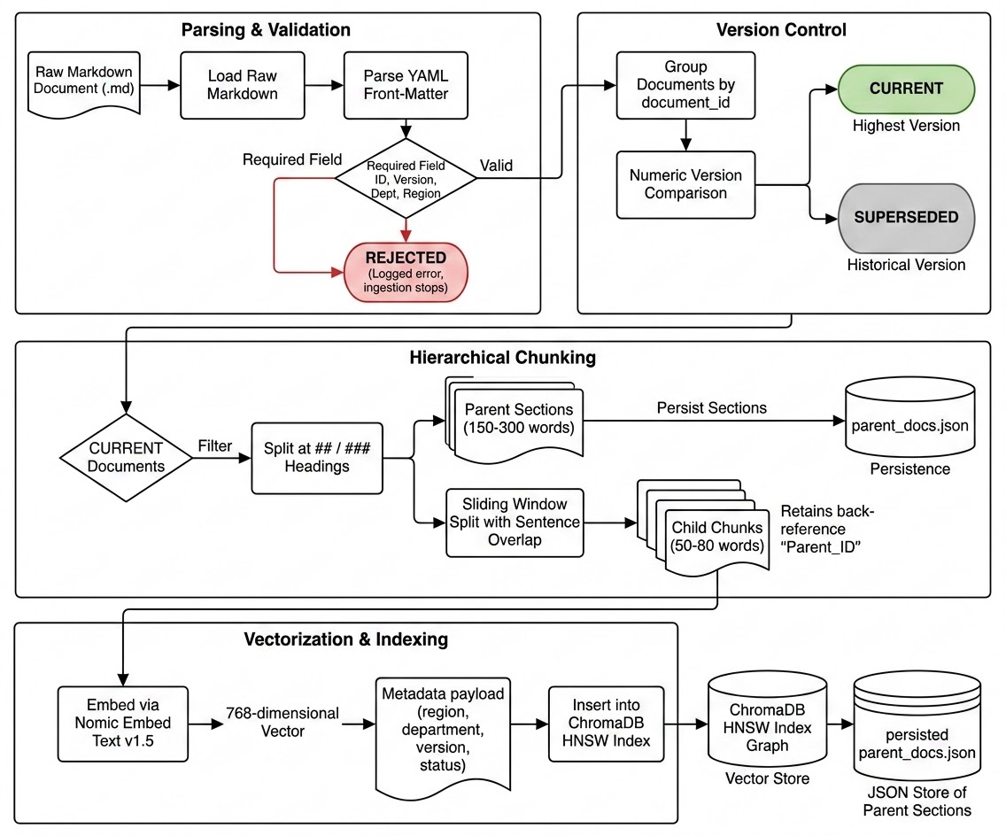

8. Retrieval Layer Architecture

8.1 Theoretical Motivation
The retrieval layer, implemented in hybrid_retriever.py, is the component responsible for the system's central promise: that any text handed to the generative model has been independently verified as relevant to the user's query. It is structured as a four-stage pipeline, including parallel dense/sparse search, Reciprocal Rank Fusion, cross-encoder re-ranking, and parent-section resolution, with each stage compensating for a specific, well-understood weakness of the stage before it.

8.2 Stage 1 — Parallel Search
Dense vector search and sparse lexical search fail on complementary, non-overlapping query types, which is the theoretical justification for running both rather than relying on either alone. Dense search excels at conceptual and paraphrase matching but can blur exact strings; an embedding model may not strongly distinguish "GDPR Article 17" from "GDPR Article 15," because both are topically about GDPR articles even though only one is textually correct for a given query. Sparse lexical search excels at exact-string precision but has essentially zero understanding of synonymy; it will not connect "device theft" to "laptop stolen" at all, since the two share no common tokens.
NomicHybridRetriever submits both searches concurrently via a Python ThreadPoolExecutor rather than sequentially, halving perceived latency. The dense search queries the ChromaDB/HNSW index (Section 7.6) for the top-N candidates by cosine similarity. The sparse search queries and in-memory BM25 index aclassic probabilistic term-frequency/inverse-document-frequency ranking function for the top-N candidates by exact and near-exact keyword overlap. Both threads return independently, and the retriever blocks until both complete, typically bounded by whichever search is slower rather than their combined sum. Legal and compliance queries are disproportionately likely to hinge on an exact regulatory citation or internal document ID, which is precisely what BM25's presence in the pipeline is designed to protect — it prevents the system from confidently retrieving the wrong GDPR article purely on the strength of topical similarity. If the BM25 index and the ChromaDB index were to fall out of sync (for instance, due to a partial ingestion failure affecting one but not the other), results would become inconsistent between the two search paths; ingestion is therefore designed to write to both indices atomically as part of a single build pass.

8.3 Stage 2 : Rank Fusion
Given two independently-ranked lists covering potentially different, only partially-overlapping sets of documents, RRF provides a principled way to merge them into a single ranking without requiring the two lists' raw scores to be on comparable scales — cosine similarity and a BM25 score are not directly comparable numbers, so naively averaging them would be mathematically meaningless. The RRF formula for a document d is:
RRF_score(d) = Σ 1 / (k + rank_i(d))
i ∈ {dense, sparse}

where rank_i(d) is the 1-indexed position of document d in ranked list i (documents absent from a list are simply excluded from that term of the sum), and k is a smoothing constant — the system uses the standard literature default of 60 — that dampens the influence of very low ranks and prevents division instability near rank 1. hybrid_retriever.py computes this score for the union of both candidate sets, then sorts descending. A document ranked #1 in both lists receives the highest possible combined score and floats to the top of the fused list; a document appearing in only one list still receives a nonzero, but comparatively discounted, score ensuring a genuinely single-signal match (a pure keyword hit with no semantic similarity, or vice versa) is not entirely discarded before the next stage has a chance to evaluate it. RRF's rank-based (rather than raw-score-based) design also means the fusion step is robust to either underlying retriever being independently tuned or swapped in the future, decoupling "how signals are merged" from the specifics of any one embedding or lexical model version.

8.4 Stage 3 : Re-Ranking
This is the single most consequential stage in the retrieval pipeline for the system's zero-hallucination guarantee, and it exists to correct a fundamental limitation shared by every stage before it.
Theoretical basis: Dense search, sparse search, and RRF fusion are all, in different ways, bi-encoder approaches : the query and each candidate document are processed independently, and similarity is computed afterward as a distance between two pre-computed representations. This is computationally cheap (document embeddings can be pre-computed offline), but fundamentally limited: the model never actually reasons about the query and the document together, and so it cannot capture fine-grained interactions such as negation ("employees are not entitled to...") or conditional exceptions. A cross-encoder, by contrast, concatenates the query and the candidate document into a single input and passes both through the transformer together, computing full self-attention across every token pair — every query word can attend to every document word and vice versa. This allows the model to detect subtle mismatches that bi-encoder cosine similarity would miss entirely — for example, a document about PTO accrual timing may superficially resemble a query about PTO total allowance in vector space, but a cross-encoder's word-level attention can recognize the two are not actually answering the same question.
Implementation: The top-N fused candidates from RRF (not the full corpus, as cross-encoders are too computationally expensive to run against every document) are passed through ms-marco-MiniLM-L-6-v2, a transformer fine-tuned specifically for query-document relevance scoring. Each candidate receives a single relevance score. Any candidate scoring below a fixed, conservatively-set threshold is discarded outright, regardless of its earlier RRF rank. Critically, if every surviving candidate is discarded by the threshold, the retriever returns an empty result set, not a low-confidence best-effort result. This propagates directly into router.py, which sets the graph state such that the downstream generation node is instructed to explicitly state that the policy could not be found, rather than attempting to answer from general world knowledge. This threshold is the direct technical mechanism fulfilling the system's "does not hallucinate" guarantee: it converts "no confident match" from a silent failure into an explicit, user-visible refusal. The threshold value itself is treated as a tuned hyperparameter, validated specifically against the Anti-Hallucination category of the adversarial evaluation suite (Section 5.7), which probes with queries about policies that do not exist in the corpus (maternity leave, or a deliberately nonsensical "peacock policy") to confirm the system correctly returns "not found" rather than fabricating a plausible-sounding answer. An overly conservative threshold increases false-negative refusals; an overly permissive threshold reduces anti-hallucination protection. The threshold is therefore an explicit, monitored trade-off rather than an arbitrary constant.

8.5 Stage 4 : Context Resolution
The child chunks that survive Stage 3 are, by design (Section 7.4), small: 50-80 words, optimized for search precision rather than generation-time completeness. Handing only these fragments to the generative model risks re-introducing exactly the context-loss problem the parent-child split was designed to solve. For each surviving child chunk, the retriever reads its stored Parent_ID back-reference and looks up the corresponding full parent section (150-300 words) from parent_docs.json. Duplicate parent sections, where multiple surviving child chunks point to the same parent, are de-duplicated before being passed downstream, so the generative node receives each relevant policy clause exactly once, in full, including any exceptions or caveats a 50-word fragment alone might have excluded. If a Parent_ID reference is found to be broken, the retriever falls back to returning the child chunk text alone with a lower-confidence flag, rather than failing the request outright.

8.6 Retrieval Flow Diagram
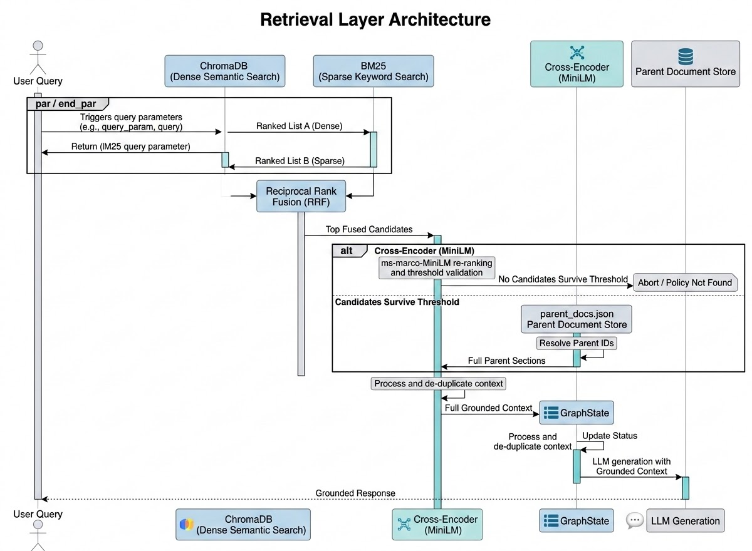

9. LangGraph Orchestration Layer

9.1 Overview
The orchestration layer is the decision-making core of the system. It is implemented as a compiled LangGraph StateGraph, which is a directed graph of node functions connected by conditional edges, threading a single typed state object through every step of execution. This section describes the state schema, the router's internal logic in full granularity, each node's execution modality, and the complete conditional-edge routing table.

9.2 GraphState Schema
A state machine's correctness depends entirely on its state schema being complete; every piece of information any node might need to make a decision must be representable in the schema, or the graph would require out-of-band side channels that undermine auditability. state.py defines GraphState as a strictly typed dictionary:

Field | Type | Populated By | Purpose
query | str | Entry point / clarify_node on resume | The current, possibly context-merged, user query
session_id | str | Entry point | UUID used for session cache lookup
parameters | dict | router_node | Extracted region/department from the query
intent | str | router_node | One of ESCALATE, MULTI_HOP, CLARIFY, ANSWER_DIRECT
retrieved_docs | list | router_node (via hybrid retriever) | Parent sections surviving the retrieval pipeline
has_contradiction | bool | router_node (Contradiction Engine) | Whether conflicting regional documents were found
response | str | Terminal node (clarify / escalate / multi_hop / answer_direct) | Final generated or hard-coded response text
citations | list | Terminal node | Versioned document references backing the response

Every node function has the uniform signature (state: GraphState) -> GraphState; it reads whatever fields it needs, returns an updated state, and LangGraph merges the result back into the running state object before evaluating the conditional edges in agent_graph.py to determine the next node. Because the entire decision trail, including extracted parameters, classified intent, the contradiction flag, and the exact retrieved sources, is captured in one serializable object, GraphState at any point in execution can be logged and later reconstructed for audit. The reason for a response has a literal, inspectable answer, not a black-box LLM output. As a final integrity check, a node that fails to populate a required downstream field is caught by response-shape validation at the Pydantic layer before the API serializes the outbound ChatResponse; the network boundary itself acts as a last-line schema guarantee.

9.3 Router Logic
router_node is the single entry point for every query and performs three sequential operations internally, each of which is described in full below.
Operation 1 –– Dynamic Taxonomy Loading. Before anything else, the router queries parent_docs.json for the current set of region and department values actually present in the index. This is what allows the system's taxonomy to grow with zero code changes; dropping a new hr_policy_apac_singapore_v1.0.md file into /sample_docs and re-indexing makes "Singapore" an available disambiguation option automatically, because the router discovers it dynamically rather than having it hardcoded into a prompt.
Operation 2 — LLM-Based Parameter and Intent Extraction. The router prompts NVIDIA Nemotron with the user's query and the dynamically-loaded taxonomy from Operation 1, asking it to (a) extract any region or department explicitly stated in the query, and (b) classify the query's intent into exactly one of the four categories: ESCALATE, MULTI_HOP, CLARIFY, or ANSWER_DIRECT. This is a probabilistic classification step; it is the LLM's best judgment given the query text.
Operation 3 — Contradiction Evaluation (Deterministic Override). The router now inspects the region metadata across all documents returned by the retrieval pipeline (Section 8). If more than one distinct region is represented among the high-confidence results and the user did not specify a region in Operation 2, has_contradiction is set to true and intent is force-overridden to CLARIFY, regardless of what the LLM classified in Operation 2. This override is deliberate and structurally important: the Contradiction Engine's decision is authoritative over the LLM's own intent classification; a probabilistic model's output is never allowed to bypass a deterministic conflict check. The one exception is when the query's own phrasing indicates an explicit comparison request; in that case the query is routed to answer_direct_node with an instruction to build a comparative matrix rather than to clarify_node, since the multi-region result set was intentional, not ambiguous.

9.4 Edge Routing Table
The compiled graph in agent_graph.py evaluates the following routing logic immediately after router_node completes:
Condition Evaluated | Destination Node
has_contradiction == true (force override, evaluated first) | clarify_node
intent == "ESCALATE" | escalate_node
intent == "MULTI_HOP" | multi_hop_node
intent == "ANSWER_DIRECT" | answer_direct_node

Note that the contradiction check is evaluated with the highest precedence; it can override an ANSWER_DIRECT or even an ESCALATE classification if a genuine regional conflict is detected, since resolving ambiguity is treated as a logical prerequisite to any other action.

9.5 Node Execution Detail
clarify_node — Ambiguity Resolver. Triggered whenever has_contradiction is true. This node does not call the generative LLM at all. It constructs a deterministic disambiguation payload, which is the list of conflicting regions found in the retrieved set, and writes the current GraphState into session_cache.py (Section 10), keyed by session_id, so execution can resume once the user selects a region. The frontend mounts DisambiguationWidget.tsx in direct response to this node's output flags.
escalate_node — Legal Circuit Breaker. Triggered when intent == "ESCALATE". This node bypasses the generative LLM entirely; it returns a hard-coded refusal template plus compliance officer contact routing information. No portion of this response is model-generated, which eliminates any risk of prompt-injection-driven bypass of the escalation behavior. The primary failure mode to guard against here is under-triggering; a bribery-adjacent query phrased unusually might not be classified as ESCALATE by the router LLM. This is mitigated by keeping the escalation threshold intentionally permissive: the system is biased toward escalating borderline cases to a human rather than risking an under-triggered legal response, and boundary phrasings are continuously tested via the adversarial evaluation suite's Escalate category.
multi_hop_node — Cross-Department SOP Synthesizer. Triggered when the documents retrieved for a query span more than one department value. This node prompts Nemotron using MULTI_HOP_SYSTEM_PROMPT, which enforces three specific behaviors: a supportive tone appropriate for an active incident; synthesis into a single action plan, with the model forbidden from revealing that instructions were assembled from separate source documents; and bolding of time-sensitive actions, extracted directly from the source documents' stated deadlines and never invented.
answer_direct_node — Standard Policy Agent. The default synthesis path for single-domain, non-conflicting queries. Governed by ANSWER_DIRECT_SYSTEM_PROMPT, which enforces a first-person tone; an explicit prohibition on robotic preambles; Markdown formatting for comparisons; and a hard instruction to refuse rather than answer if retrieved_docs is empty, reinforcing the anti-hallucination guarantee at the prompt-engineering layer as well, providing defense in depth.

9.6 Orchestration State Diagram
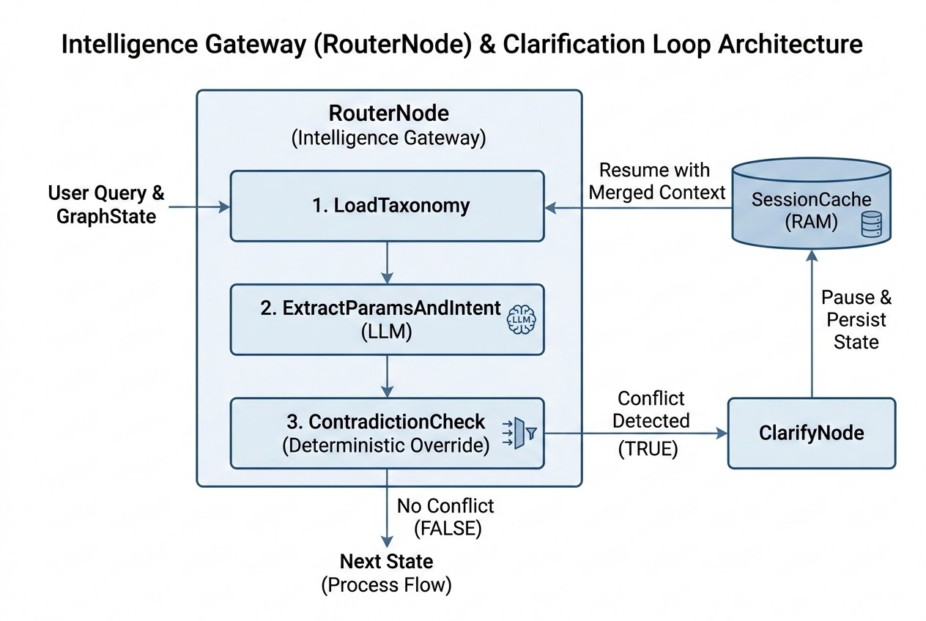

10. Session & Memory Architecture

10.1 Scope of Memory
Not every conversational system needs persistent, long-term memory. This system's genuine memory requirement is narrow and short-lived: bridging the gap between clarify_node pausing execution and the user's follow-up click resolving it, which is typically seconds or minutes if the user steps away. Provisioning a persistent database or a dedicated cache service for a requirement this narrow would add infrastructure surface area, operational cost, and, critically for a compliance-sensitive system, a persistent record of user queries that does not need to exist at all.

10.2 TTL Cache Design
session_cache.py implements a thread-safe, in-memory Dict[str, dict] living directly in the FastAPI process's RAM. Each active browser tab is assigned a UUID session_id by the frontend at load time. When clarify_node pauses execution (Section 9.5), it writes the paused GraphState into this dictionary keyed by session_id, along with a last_accessed timestamp. A background garbage-collection task runs on a periodic interval, sweeping the dictionary and permanently deleting any entry whose last_accessed timestamp is older than 30 minutes.
This design satisfies two enterprise requirements simultaneously. First, data privacy: because the cache is in-memory only and aggressively expired, a user's in-progress query cannot be recovered by a database backup, a disk forensic tool, or a server restart. Second, memory stability: without the TTL sweep, an in-memory dictionary under sustained load would grow unbounded and eventually cause an out-of-memory crash; the 30-minute expiry provides a hard upper bound on cache size proportional to active users over 30 minutes, rather than total historical usage.
The accepted trade-off is that if the FastAPI process restarts while sessions are pending, all in-flight disambiguation state is lost and a user mid-clarification would need to re-ask their original question. This is judged acceptable because the alternative directly conflicts with the privacy rationale above; the system prioritizes data minimization over conversational continuity across process restarts.

10.3 Context Merging
When the user selects a region on the frontend (for example, clicking "US-NY"), the frontend issues a new POST /api/chat request containing that selection and the existing session_id. The backend then: (1) queries session_cache.py using the UUID to retrieve the paused GraphState; (2) merges the new input into the original query, rewriting it internally to a form such as "Context: US-NY. Query: What is the PTO policy?"; (3) updates the last_accessed timestamp on the retrieved session; and (4) re-enters router_node with this fully-resolved query, at which point the Contradiction Engine (Section 9.3) finds no remaining conflict and the graph proceeds to answer_direct_node as normal.

10.4 Lifecycle Diagram
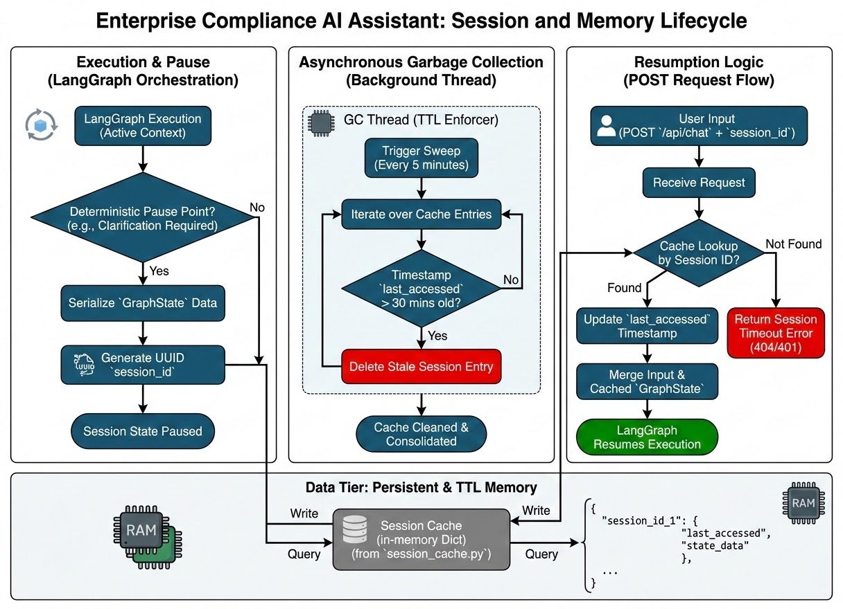

11. Frontend Layer

11.1 Architectural Role
The frontend is deliberately architected as a state-reflection engine, not an independent decision-maker. Every meaningful UI state, including which component is mounted and which buttons are shown, is a direct function of the GraphState-derived payload returned by the backend. This keeps all safety-critical logic entirely server-side, where it can be tested, audited, and protected from client-side manipulation. A compromised frontend build cannot suppress the escalation banner without also losing the ability to render correct responses, because the safety flag and response content are delivered together as one payload.

11.2 Composition
main.tsx mounts the root <App /> component into the page's DOM node, establishing the single React tree for the application. App.tsx owns global conversation history and session identity, generating and persisting the per-tab session_id UUID consumed by the backend's TTL cache. index.css defines the shared design tokens, which include the color palette, layout spacing, and component styling, applied consistently across all components and deliberately isolated from application logic. lib/api.ts provides a typed client wrapping all fetch calls to the FastAPI backend, and types.ts mirrors the backend's GraphState and response schemas in TypeScript, ensuring the network boundary is type-safe.

11.3 Dynamic Mounting
The interface does not passively display a single response format; it actively reconfigures itself based on boolean flags embedded in the backend's response payload:
- Escalation modality: When the response includes requires_escalation: true, the React tree dynamically mounts EscalationBanner.tsx, rendering a high-visibility warning block with compliance officer contact information.
- Disambiguation modality: When the response's intent field equals CLARIFY, the React tree mounts DisambiguationWidget.tsx, which intercepts the standard text input and instead presents a constrained set of clickable region options, ensuring the user cannot accidentally free-type an ambiguous follow-up that the router would need to re-classify from scratch.
- Standard response modality: In all other cases, MessageBubble.tsx renders the response as Markdown (via React Markdown with GitHub-flavored Markdown support), including any comparative tables generated by answer_direct_node, alongside CitationCards.tsx, which formats the versioned document references returned with the answer.

11.4 Supporting Components
Sidebar.tsx manages chat history navigation; ChatHeader.tsx renders the application's top bar, including a live backend-health indicator driven by useHealth.ts, which polls /api/health in the background. WelcomeScreen.tsx presents suggested starter queries before the first message is sent. InputBar.tsx manages text entry, submission events, and loading state, working in concert with TypingIndicator.tsx, which renders an animated loading indicator while the backend executes the pipeline.

11.5 Design Boundary
The frontend's responsibility ends at faithfully reflecting the backend's decisions in the interface; it performs no independent classification, filtering, or safety logic of its own. This boundary is intentional and directly supports the audit requirement: because the escalation and clarification UI states are driven entirely by explicit backend flags, the frontend cannot introduce a divergent or inconsistent safety behavior relative to what the backend actually decided.

12. Conclusion
The Enterprise Compliance AI Assistant demonstrates that the risks associated with deploying generative AI in regulated enterprise contexts, including hallucination, regional policy conflation, unauthorized legal guidance, and siloed incident response, are not inherent to the technology, but are consequences of architectural choices that trust generation to self-regulate. This system's central architectural contribution is the systematic replacement of soft, prompt-level constraints with hard, structural ones: a cross-encoder relevance gate that can return nothing rather than guess; a Contradiction Engine whose deterministic override cannot be reasoned around by the LLM's own classification; a Legal Circuit Breaker that removes the generative model from the response path entirely for high-risk query classes; and a LangGraph state machine whose conditional edges make every routing decision auditable as a literal, inspectable trail rather than an opaque model output.
The result is a system where every possible execution path terminates in one of four well-defined, safety-reviewed outcomes: a cited answer, a clarification request, a synthesized multi-department plan, or a hard human escalation. This pattern, including verification before generation, deterministic overrides of probabilistic classification, and hard circuit breakers for high-risk domains, generalizes beyond this specific compliance use case to any enterprise AI system operating in a domain where the cost of a confident, plausible-sounding wrong answer materially exceeds the cost of a system that occasionally, correctly, says "I don't know" or "let me connect you with a person who can help."

End of Technical Architecture Documentation.

